**Decision Tree**

**Company Data Solution**

* The output data here is provided in numerical format, continuous data. Before moving further we need to categorize it. By understanding the business moments, we can categorize the data in following manner:

1. Sales:

* We can divide sales in 3 categories:
* Less than 5000$ = Low Sale
* 5000 – 9000$ = Medium Sale
* Above 9000$ = High Sale
* After conducting Decision tree analysis I have achieved following tree:

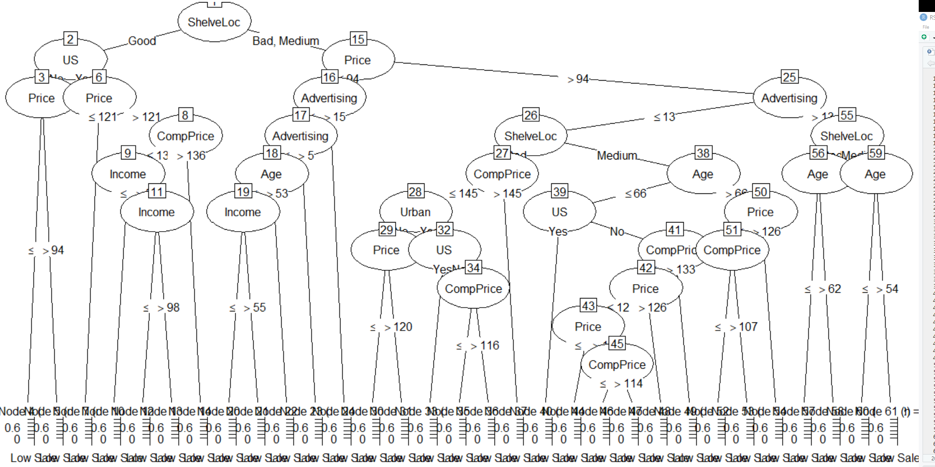

**Fraud Check Solution**

* The output data here is provided in numerical format, continuous data. Before moving further we need to categorize it. By the given boundary condition we can categorize them:
* Taxable_income:
* Less than equal to 30000 = Risky
* Above 30000 = Good
* After conducting Decision tree analysis using C5.0 I have achieved following tree:

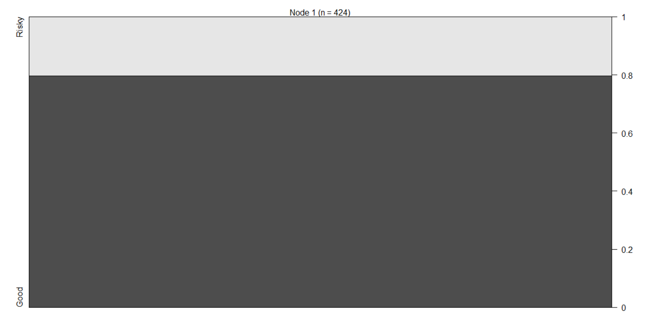

Which seemed to be biased.

* So, I conducted the anlaysis again using tree algorithm and achieved following tree:

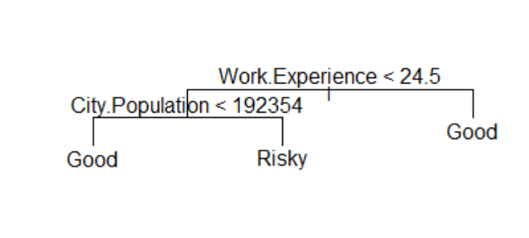

* I think the data is insufficient which is leading to biased results.